The comments displayed in the below samples explain each change made in the edits. In actual edits, however, we do not provide comments for every language change. Instead, we use Remarks and Tags to communicate with the author.

1. Introduction
Green’s theorem gives the relationship between a line integral around a simple closed curve C and a double integral over the plane region D bounded by C. This theorem is an application of the fundamental theorem of calculus to integration of a certain combination of derivatives over a plane. It can be proven easily for rectangular and triangular regions. As both sides of its equality are finitely additive and almost all planar regions can be divided into triangles and rectangles, the result holds for any planar region. This proves the theorem for reasonably shaped regions. Its generalization to non-planar surfaces (proved directly by using the finite additivity of both sides) is Stokes’ Theorem described below.
1.1 Greens’ Theorem
The formal statement of Green’s theorem is as follows: Let S be a sufficiently nice region in the plane, and let S be its boundary. Then, we have
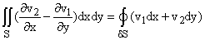
where the boundary S is traversed counterclockwise on its outside cycle (and clockwise on any internal cycles as you can verify using zippers).
Meaning of this theorem: Green’s theorem is a form that the fundamental theorem of calculus takes in the context of integrals over planar re [Remark 1]
For a rectangle: By the ordinary fundamental theorem of calculus, we have
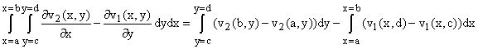.
For a right triangle: For convenience, we choose a triangle bounded by line x = 0, y = 0, and 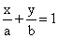.
We similarly get
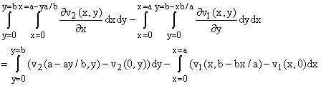.
Rearrangement of the right hand side gives the theorem for rectangles and right triangles.
It means that for R, a rectangle or right triangle in the x-y plane (for which dS = dSk), we have
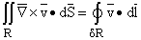.
Both sides of this equation are finitely additive, that is, if we take two disjoint regions and evaluate either one over both, we get the sum of their values on the two regions separately. This is true even if the regions share a common boundary, because the line integrals will cancel out over the common boundary that ceases to be a boundary.
The result follows from additivity for any region that can be broken up into rectangles and triangles, which accounts for most regions we will encounter.
Remark 1
Note that the sentence is incomplete. Do you mean “planar regions”?

